Front End Filter Design

Part of our practicum project involves the front end design for the CubeSat transceiver. This includes the signal filter(s), external signal amplification, and system antenna.

*Antenna and Filter(s)*

There are two possible modes of operation for the transciever:

1) Single bidirectional port

a) This requires a single antenna, a single filter, and an optional power amplifier (to boost the signal).

b) The low pass filter provided in the documentation seems to work great as a bidirectional filter.

2) Dual port

a) Here, we will construct two separate RF paths to the antenna; one path will act as the TX and the other as the RX.

b) An external switch is required to switch the antenna between the receiver and transmitter.

C) An optional external power amplifier can be included to boost the signal.

*LTSpice simluations*

Starting with the low pass filter that is included in the data sheet (KW01DHRM Rev 1/2014;

1) Modified the two inductor values from 12nH to 14nH .

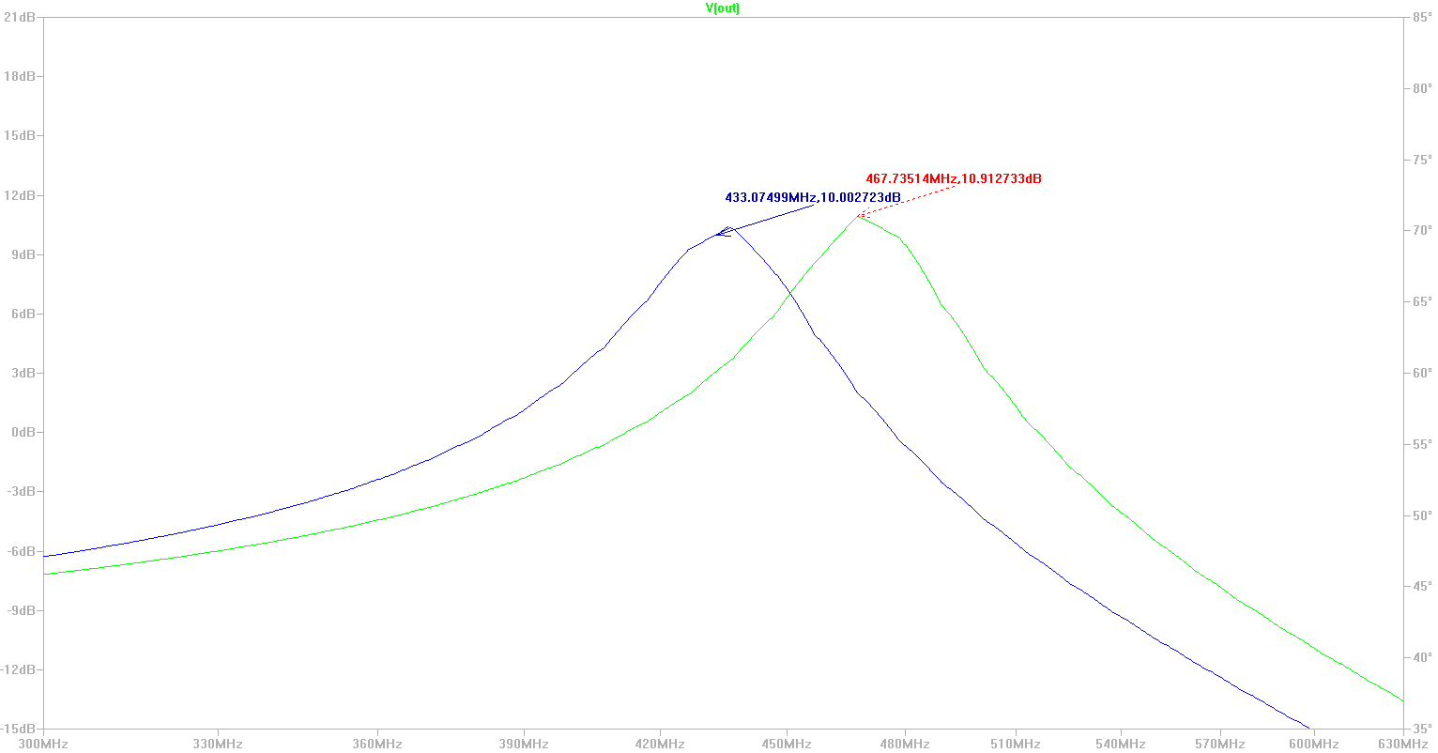

The green plot shows the frequencies that are passed using the original inductance of 12nH and the blue plot shows the result of using 14nH.

2) As noted above, this filter works fine for the bidirectional design.

Note the input and output of the filter can be switched without much loss in attenuation. A 50Ω load is used since the system expects a 50Ω connection to the antenna.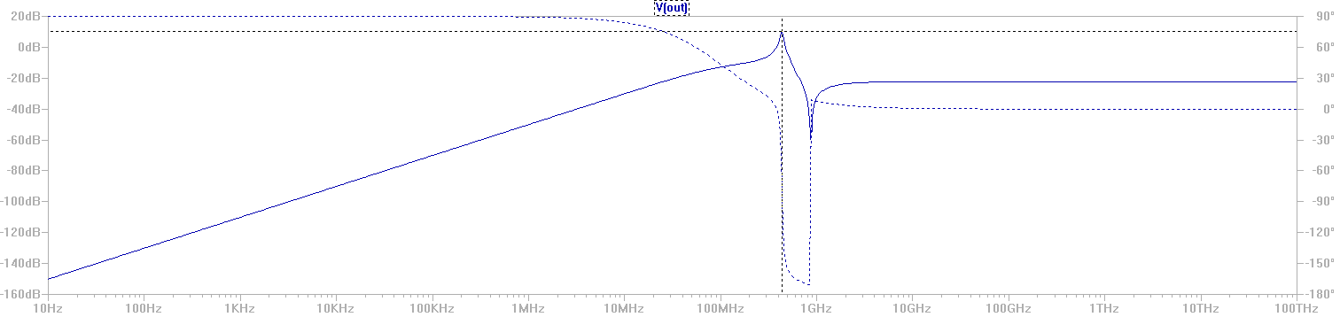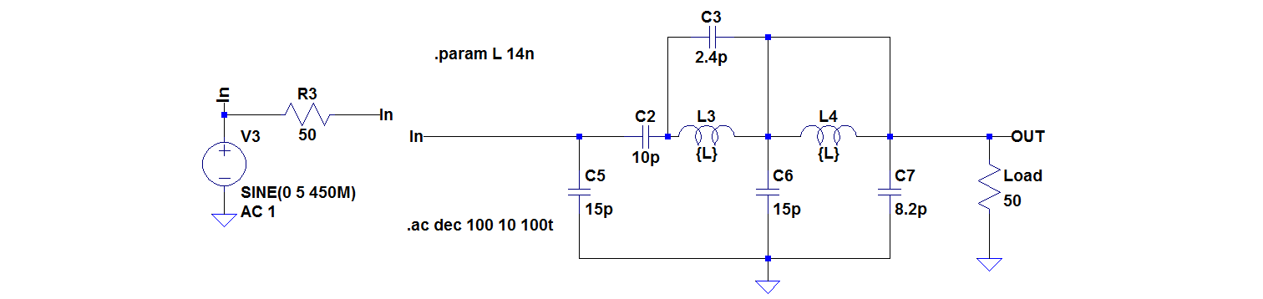

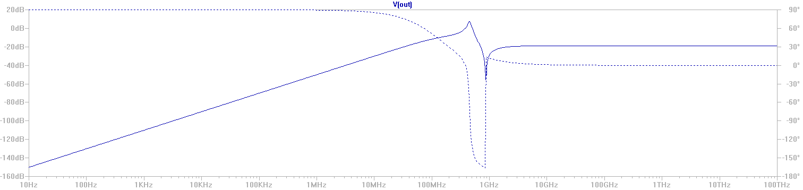

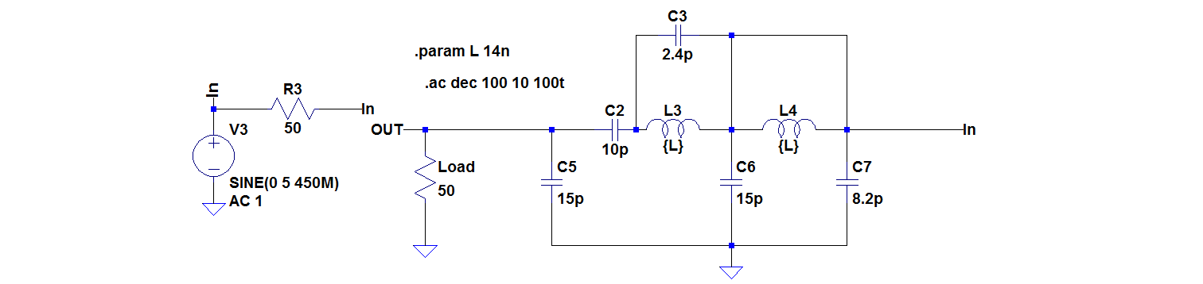

3) To improve the filter, I decided to include a low pass filter to remove any potentially unwanted harmonics. Below is a simulation to show the addition to the previous filter design.

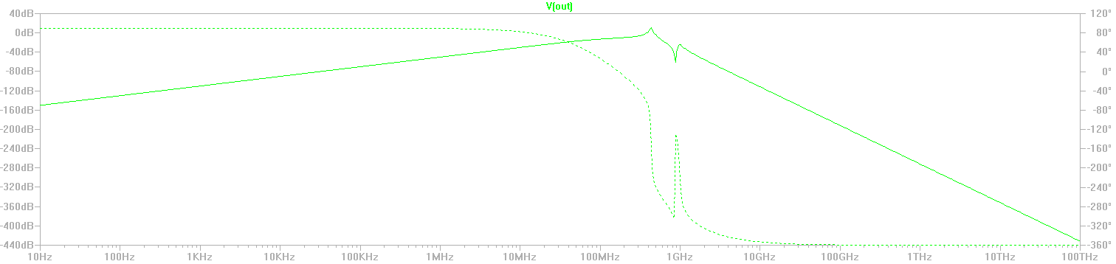

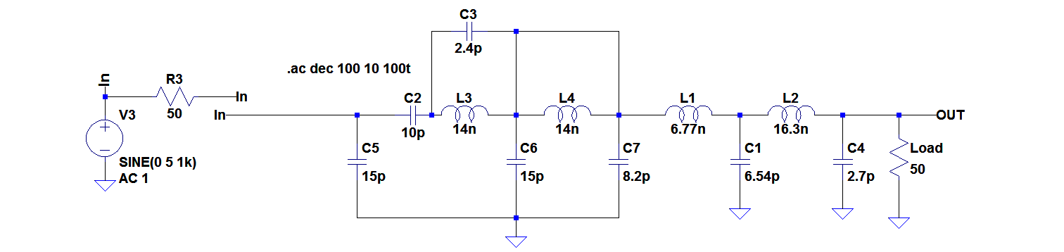

Here, the gain of the filter is virtually unaffected when used as the filter on the TX; however, as seen below, the filter does not behave well as a RX filter.

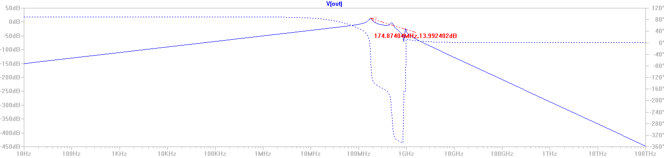

This filter would still be an improvement if we use the dual port design

4) To improve the attenuation of the lower frequencies, I included another 2nd order high pass filter. This filter is shown below.

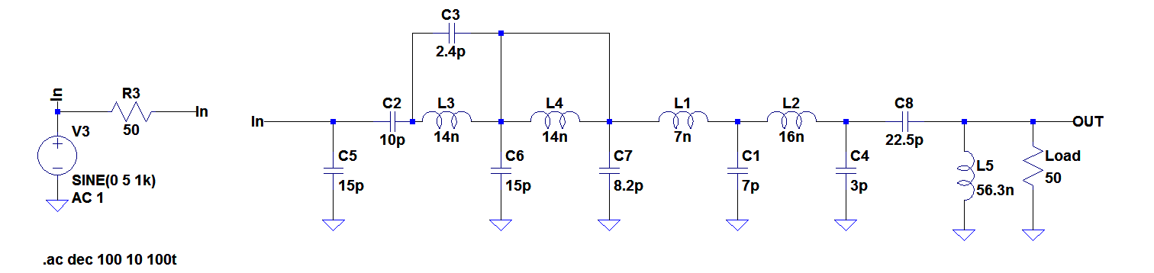

And the results are shown on the following page.

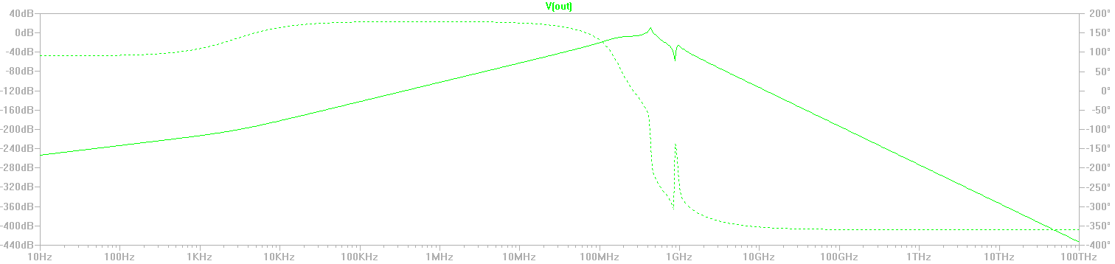

As can be seen, below, the filter is still doing a great job passing the 433MHz signal

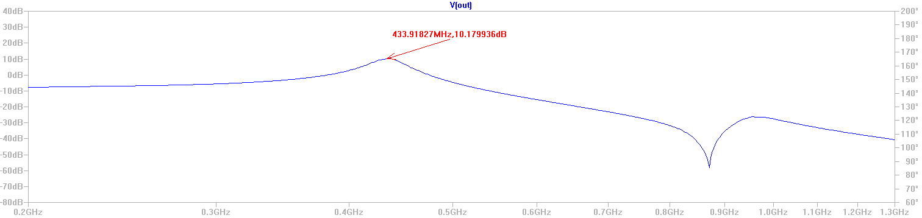

Again, this filter is only going to function as a transceiver filter. So, should only be used if we decide on the dual port design.

*Notes*:

1) We still need to determine whether we want to use the single port or dual port design. I am fairly sure that Andrew requested the dual port design, but if we are going to half-duplex the system it may not be necessary.

2) For either design, a PA filter is most likely needed. There is an internal PA that can be programmed. This will need further documentation.

3) The antenna design still needs attention. We need to discuss and decide on a type of antenna. Also, I like the idea of making and testing several prototypes before getting too deep into any single design. We should look at what other CubeSat antenna designs are like.